石军兵
姓名 | 石军兵 | 性别 | 男 | 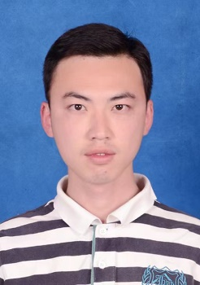
学历 | 博士研究生 | 学位 | 博士
院系 | 城市建设交通学院 |  | 专业技术职务  及专家称谓 | 助教
邮箱 | 759148519@qq.com
主要研究领域  及方向 | 相变热功能水泥基复合材料、墙体保温材料、相变储能材料
个人  简历 | 2008.09-2012.06 洛阳理工学院 材料系 无机非金属材料 工学学士  2012.09-2015.06 西南科技大学 材料学院 材料科学与工程 工学硕士  2015.09-2021.9 东南大学 材料学院 材料科学与工程 工学博士
近五年主要科研项目 | 国家自然科学基金重点项目 面向绿色建筑和智能制造的结构-功能一体化水泥基复合材料 项目参与人
主要成果（论文、著作、专利等） | 发表论文  [1] Shi junbing; Min Li ; Lightweight mortar with paraffin/expanded vermiculite-diatomite composite phase change materials: Development, characterization and year-round thermoregulation performance, Solar energy, 2021, 220: 331-342  [2] Shi junbing, Li Min. Synthesis and characterization of polyethylene glycol/modified attapulgite form-stable composite phase change material for thermal energy storage [J]. Solar energy, 2020, 205:62-73  [3] Shi junbing, Li Min. Surface modification effects in phase change material-infiltrated attapulgite [J]. Materials Chemistry and Physics, 2020, 254:12351  [4] Li Min, Shi junbing. Review on micropore grade inorganic porous medium based form stable composite phase change materials: Preparation, performance improvement and effects on the properties of cement mortar [J]. Construction and Building Materials, 2019, 194:287-310  [5] Li Min, Liu jianpeng, Shi junbing. Synthesis and properties of phase change microcapsule with SiO2-TiO2 hybrid shell [J]. Solar energy, 2018,167:158-164  [6] Lai, Zhenyu, Lai, Xinchun ; Shi, Junbing ; Lu, Zhongyuan. Effect of Zn²⁺ on the early hydration behavior of potassium phosphate based magnesium phosphate cement [J]. Construction and Building Materials, 2016, 129:70-78.  [7] 石军兵, 赖振宇, 卢忠远, 黄陈程, 廖其龙. 铅离子对复合磷酸盐磷酸镁水泥水化硬化特性的影响 [J] 功能材料, 2015,46:2060-2065.  授权专利  李敏; 石军兵 ; 一种双温度相变调温膨胀蛭石板及其制备方法, 中国, CN201910025879,
获奖
情况

